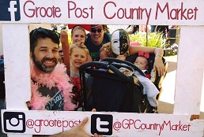

DON’T MISS GROOTE POST’S AUGUST COUNTRY MARKET
The First Market of the New Season on Sunday 25th August

Groote Post are re-opening their popular country markets for the new season. First up is the August Country Market on Sunday 25th August (from 10h00 until 15h00), followed by monthly markets on 29 September, 27 October (Country Run), 24 November and 15 December (Christmas Market).

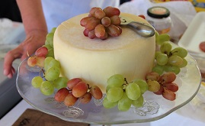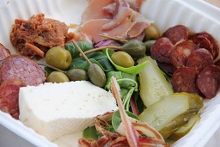

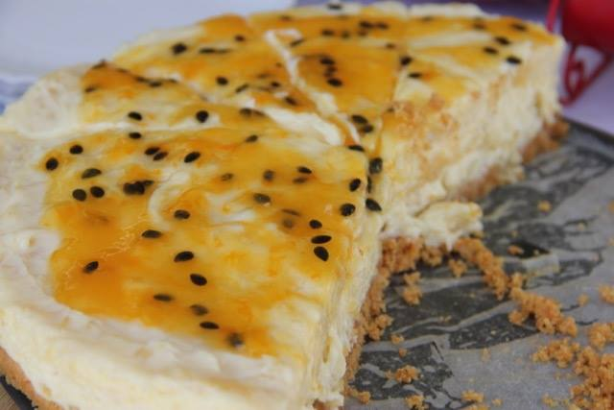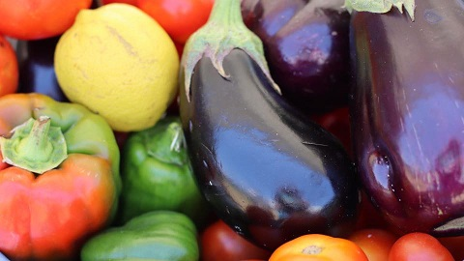

The terrace in front of Hilda’s Kitchen and adjacent to the Cellar will be brimming with market stalls offering delicious and beautiful country offerings including artisan foods, arts and crafts, homeware, clothing, décor, gifts, jewellery, accessories, toys, fresh produce and more. Local is always lekker at Groote Post, with a divine selection of Darling gourmet produce including: Weskus Worswa, Darling Honey, Burger Fellas, Darling Sweet, Nellies Homemade Pies, the popular Darling Brew and of course Groote Post’s well-loved wines.

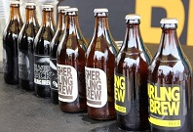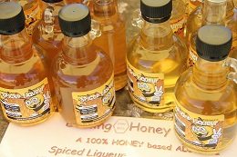

Family-friendly activities will as always be a priority. Kids will be kept busy with various kiddies’ activities: tractor rides, guided horse rides, the popular playground and more.

The Three Market Lucky Draws will take place at 12h30, 13h30 and 14h30, the winners each receiving a hamper with products from the market and Groote Post wine, but you must be present at the draw to win.

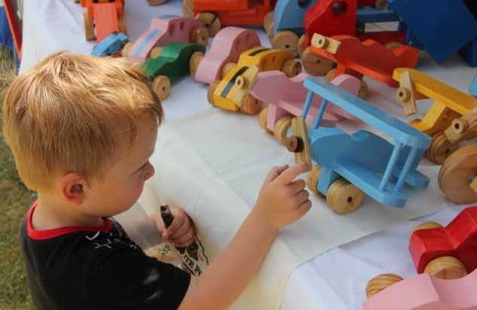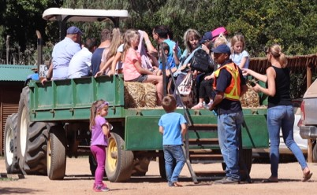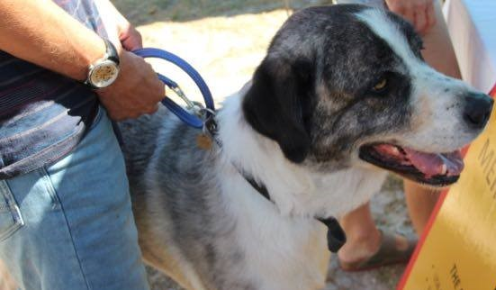

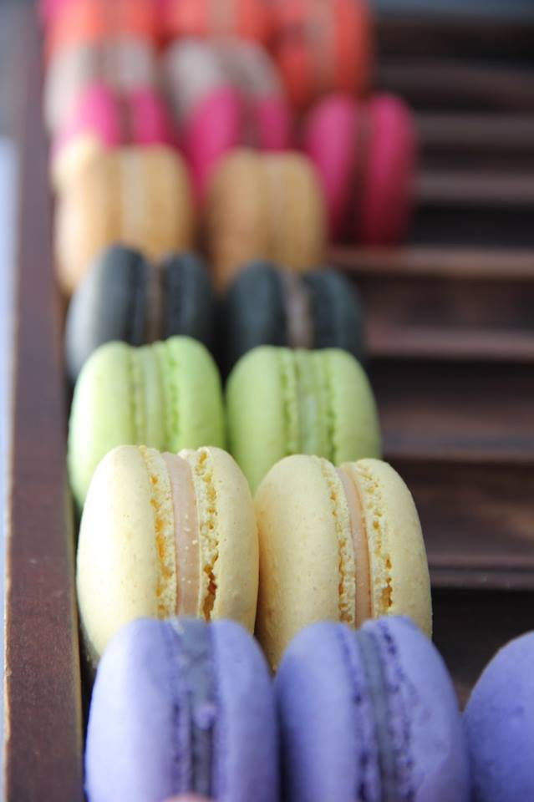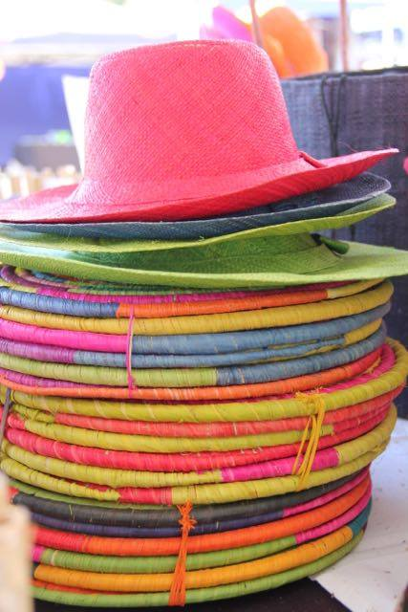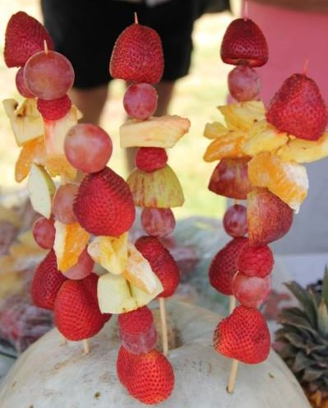

The Groote Post Market is an outing for the whole family including one’s furry children, but dogs must please be kept on a leash at all times.

- Entry to the Groote Post Country Market is free of charge.
- Groote Post Country Market opening hours: 10h00 to 15h00

For further information on the Groote Post Country Market
Contact I Love Yzer: 022 451 2202 or info@iloveyzer.co.za
www.grootepostcountrymarket.co.za · Facebook.com/GrootePostCountryMarket · @GPCountryMarket

Groote Post Estate: Only an hour’s drive from Cape Town, the historic Groote Post farm, owned by the Pentz family and situated in the Darling Hills, presents a rustic and rural atmosphere with undulating hills, vast open spaces and warm country hospitality. In addition to a wide range of award-winning wines, Hilda’s Kitchen’s superb culinary experience and Farm Drives through the private game camp and vineyards, Groote Post also offers spectacular views of the Atlantic coast and Table Mountain, nature walks, bird-watching in the hide on the dam and spectacular West Coast flowers in spring.
Directions: Follow the R27, the West Coast Road towards Langebaan. Turn right onto the Darling Hills Road opposite Grotto Bay turnoff. After 10 km, turn right to the Groote Post cellar. Alternatively, take the R307 out of Darling towards Cape Town and turn off at the Darling Hills Road. After 7 km turn left to the Groote Post Cellar.
GPS Coordinates: S 33° 29’ 0.5” E 018° 24’ 35.0
Contact: Tel: 022 492 2825 · Email: wine@grootepost.co.za · Website: www.grootepost.co.za www.facebook.com/grootepost · www.twitter.com/grootepost

